**NAAN MUDHAVAN**

**PROJECT DOCUMENT**

**COURSE TITLE** : DIGITAL MARKETING

**COLLEGE CODE**  : 1105

**COLLEGE NAME** : GOJAN SCHOOL OF BUSINESS AND TECHNOLOGY

**PROJECT TITLE** :How to create a Reel Design using canva

**PROJECT TEAM ID** : NM2023TMID05702

**TEAM LEADER**

**NM ID** : 5E3431D1589F6A88E8149456869834D3

**NAME** : LOKESH.A

**TEAM MEMBER 1**

**NM ID** : D2D5837AF13278892304C22F0B486F98

**NAME** : RANJITHKUMAR.K

**TEAM MEMBER 2**

**NM ID** : 413CF44DD41D9C2B7834C927CAF7B935

**NAME** : AKASH.R

**TEAM MEMBER 3**

**NM ID** : 25D5EEDF65487259E514D17DBD367472

**NAME** : ARUN.B

**BRAND NAME** : PIZZA PICOSSO

**BRAND MAIL-ID** : pizzapicosso1612@gmail.com

**PASSWORD** : loripizza1612

**SOCIAL MEDIA LINK** : .https://www.facebook.com/profile.php?id=61552307895208&mibextid=ZbWKwL

**DRIVE LINK** : https://drive.google.com/drive/folders/0AHS3mh-9SLrkUk9PVA

**How to Create a Reel Design Using Canva**

1. **Setting Up canva**

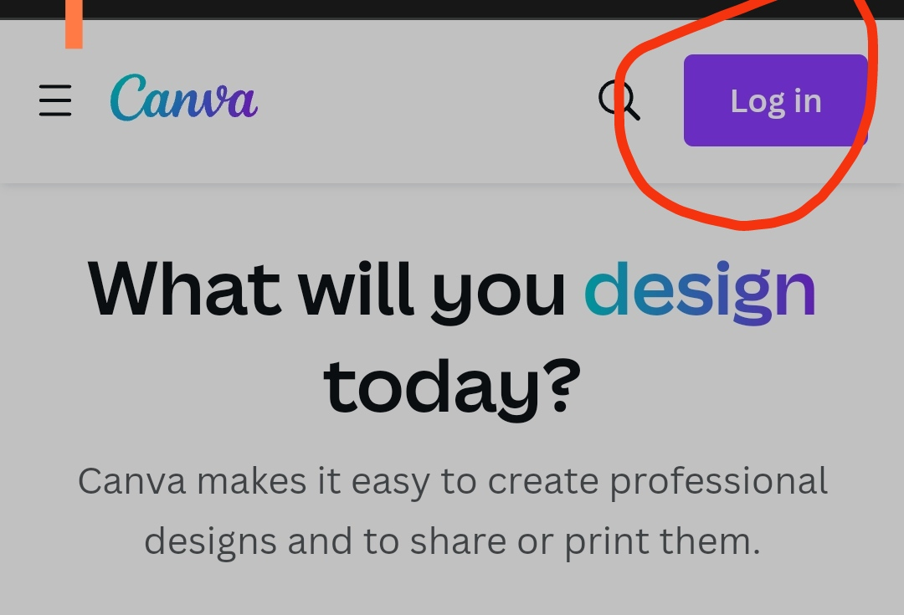

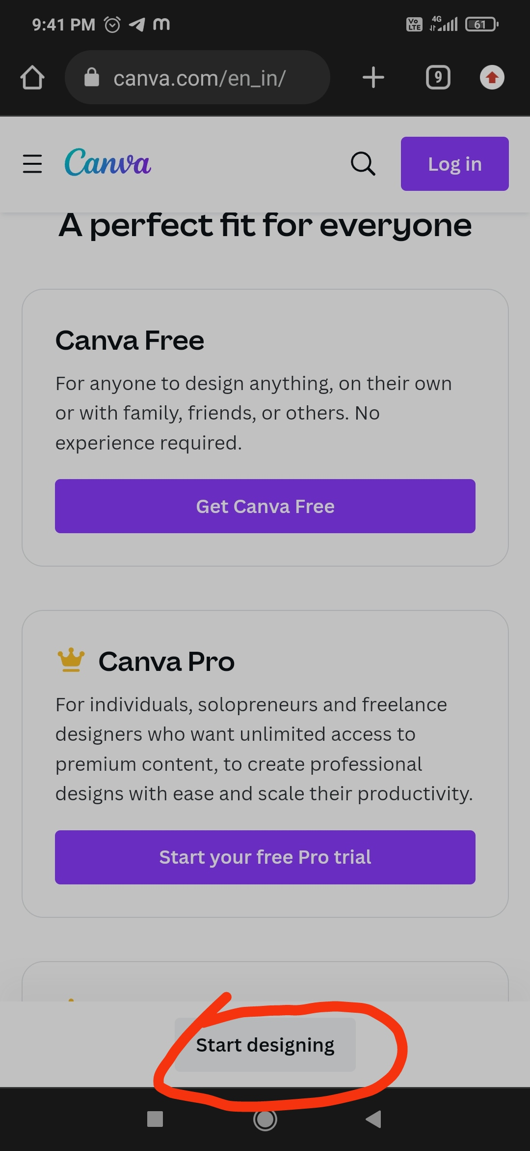

To create a reel design using Canva, follow these steps:

1. **Log In or Sign Up:**

- If you haven't already, sign in to your Canva account or create a new one.

2. **Start a New Design:**

- Click on the "Create a design" button.

- In the search bar, type "Instagram Reel."

3. **Choose a Template:**

- Canva offers a variety of Instagram Reel templates. Browse through them and select one that suits your style or purpose.

4. **Customize the Template:**

- Once you've selected a template, you can customize it. This includes changing text, colors, images, and more.

- You can upload your own images or use Canva's vast library of stock photos and illustrations.

5. **Edit Text and Elements:**

- Click on any text or element in the template to edit it. You can change the text, font, size, color, and alignment.

- Add your captions, hashtags, or any other text you want to include in your reel.

6. **Add Your Content:**

- You can upload your video or image content directly to the template.

- Canva provides a video editor, so you can trim or adjust your videos within the platform if needed.

7. **Arrange and Resize:**

- Arrange the elements, text, and content to create an appealing design.

- Resize and reposition elements to fit your content properly.

8. **Preview and Save:**

- Preview your design to make sure it looks how you want it to.

- Once satisfied, click on the "Download" button to save your reel design to your device.

9. **Upload to Instagram:**

- Now, you can upload the designed reel to Instagram as you usually would.

10. **Share and Interact:**

- After sharing your reel, engage with your audience by responding to comments and monitoring its performance.

That's how you can create a reel design using Canva. Make sure to tailor the design to your specific needs and preferences, and have fun with the creative process.